Create Table :-

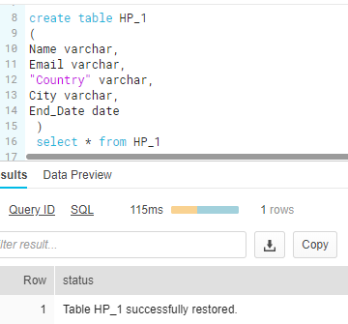

Drop Table:-

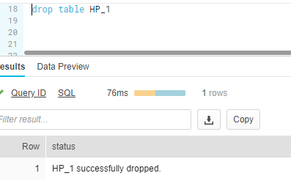

Undrop Table:-

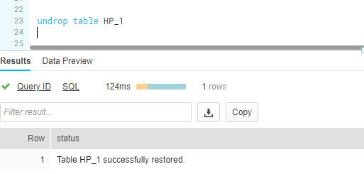

Stage:-

 loading data from files into Snowflake tables and unloading data from tables into files.

Internal stage: Store data files internally within snowflake.

External stage: References data files stored in a location outside of snowflake.

|  |  |  |
| --- | --- | --- |
|  |  |  |
|  |  |  |

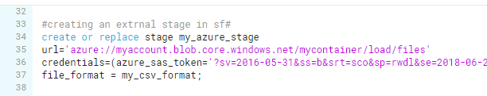

Copy:-

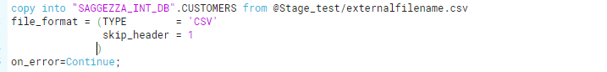

Time travel:-

Time travel is a build quarry data as of us specific data or time in a task.

selects historical data from a table as of the date and time represented by the specified timestamp.

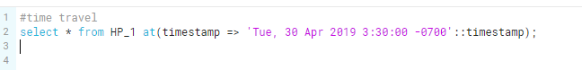

Cloning:-

Clone any data base object or clone entire data base which can be vary variable.

Cloning, also referred to as “zero-copy cloning,” creates a copy of a database, schema or table.

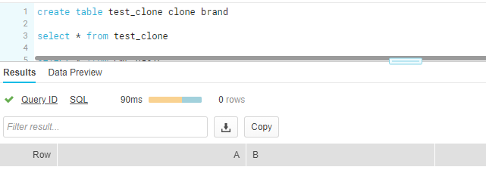

Functions:-

1. [Scalar Functions](https://docs.snowflake.net/manuals/sql-reference/intro-summary-operators-functions.html#scalar-functions)
2. [Aggregate Functions](https://docs.snowflake.net/manuals/sql-reference/intro-summary-operators-functions.html#aggregate-functions)
3. [Window Functions](https://docs.snowflake.net/manuals/sql-reference/intro-summary-operators-functions.html#window-functions)
4. [Table Functions](https://docs.snowflake.net/manuals/sql-reference/intro-summary-operators-functions.html#table-functions)
5. [System Functions](https://docs.snowflake.net/manuals/sql-reference/intro-summary-operators-functions.html#system-functions)
6. [User-defined Functions (UDFs)](https://docs.snowflake.net/manuals/sql-reference/intro-summary-operators-functions.html#user-defined-functions-udfs)

[User-defined Functions (UDFs)](https://docs.snowflake.net/manuals/sql-reference/intro-summary-operators-functions.html#user-defined-functions-udfs):-

Snowflake currently supports two types of UDFs,SQL and JavaScript

For the numeric:-

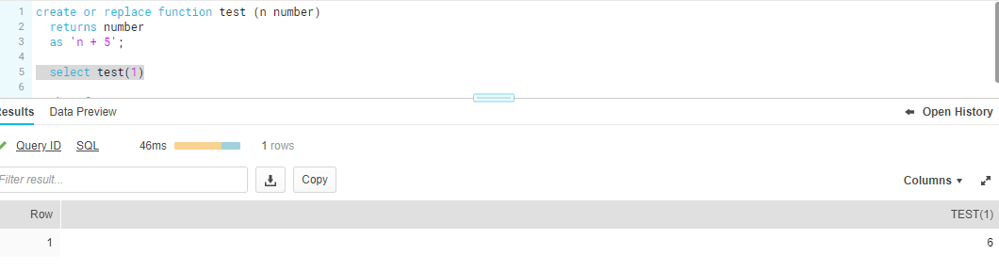

For string:-

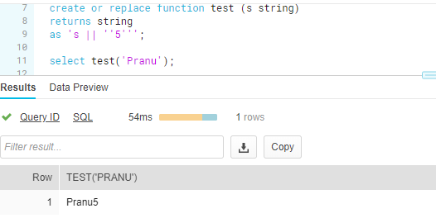

Date:-

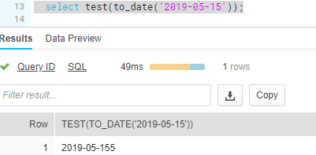

single quotes are used to escape the string literal ''. Any single quotes used in a UDF definition must be escaped by single quotes.

Stage:-

SHOW STAGES:

Lists all the stages for which we have access privileges.

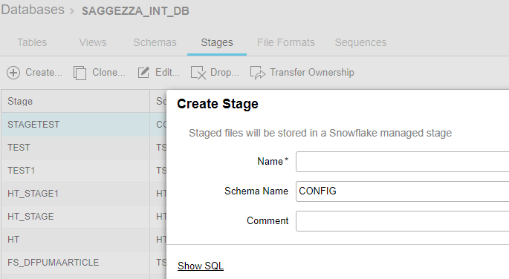

snowsql -a saggezzapartner.us-east-1 -u PKURAPATI -d SAGGEZZA_INT_DB -s INFORMATION_SCHEMA -w SAGGEZZA_WH

PUT:-Put command is used to load the data from local machine to internal stage in snowsql

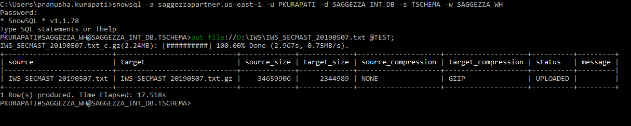

Get:

Get command is used to load the data from internal stage in snowflake to local machine\directory

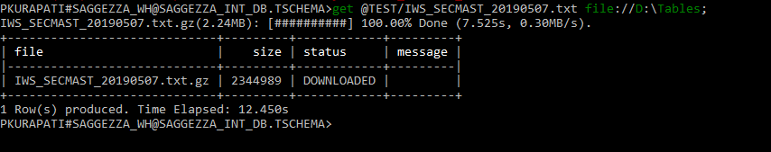

GET @TEST FILE ://D:\Tables;

File Formate:-

Creates a named file format that can be used for bulk loading data into (and unloading data out of)

Snowflake tables.

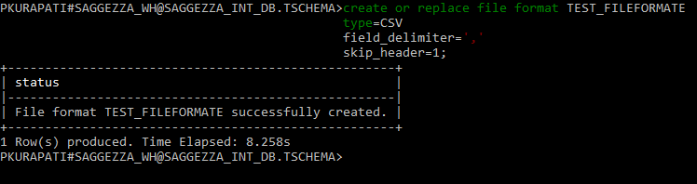

File Format:-

